



If you’re a parent concerned about bullying, it’s important to recognize the signs that a child is a bully, as well as the signs of one who is being victimized. This is especially true if your child has a learning disability (LD), Attention-Deficit/Hyperactivity Disorder (AD/HD), Autism, or any condition or component of their personal make-up which might make them more likely to be targeted for bullying. Being alert and observant is critical, since victims are often reluctant to report bullying. Many victims don’t report it to their parents or teachers because they’re embarrassed or humiliated by the bullying. They may assume that adults will accuse them of tattling or will tell them to deal with it themselves. Some victims believe there is nothing adults can do to get the bully to stop. Naturally, bullies don’t discuss their misdeeds with their parents or teachers. If their bullying behavior is reported and their parents confront them, bullies usually deny their involvement.

It is critical that parents, students, and school officials understand the differences between bullying and other forms of peer conflict. The essential components of bullying are an imbalance of power (e.g. size, age, social status, or numbers) and intent to cause harm (physical, social, or emotional). Most bullying will also involve a repeated pattern of behavior, but it is not necessary to establish this, in order to meet the definition of bullying. In this age of technology, the imbalance of power may not exist at the time rumors or other attempts at social isolation are made through any electronic device. This still may meet the criteria of bullying, and if it’s found to interfere with the educational opportunity of any child, or disrupt the academic environment of a school, we can and will take any action necessary to stop the problem.

The Victim: Signs and Symptoms
A child who is a victim of bullying may display one or more of the following behaviors at home*:
- Comes home from school with clothing that’s torn or in disarray, or with damaged books.
- Has bruises, cuts, and scratches, but can’t give a logical explanation for how they got them.
- Appears afraid or reluctant to go to school in the morning, complaining repeatedly of headaches or stomach pains.
- Chooses an “illogical” route for going to and from school.
- Has bad dreams or cries in their sleep.
- Loses interest in school work, and grades suffer. If your child normally struggles in school because of a learning disability and is teased about having LD, school may become unbearable for them.
- Appears sad or depressed, or shows unexpected mood shifts, irritability, and sudden outbursts of temper.
- Requests money from you to meet the bully’s demands and might even resort to stealing money from you or other family members.
- Seems socially isolated, with few — if any — real friends; is rarely invited to parties or to the homes of other kids. Their fear of rejection may lead them to shun others.

The Bully: Signs and Symptoms
A youngster who is bullying other kids may display one or more of the following behaviors at home*:
- Has a strong need to dominate and subdue others; asserts with power and threats to get their own way.
- Intimidates siblings or kids in the neighborhood.
- Brags about actual or imagined superiority over other kids.
- Is hot-tempered, easily angered, impulsive, and has low frustration tolerance. Has difficulty conforming to rules and tolerating adversities and delays. If they have the impulsive/hyperactive type of AD/HD, that could explain some of these behaviors; if so, it’s important to work with their doctor and teachers to address and manage such behaviors.
- Cheating
- Oppositional, defiant, and aggressive behavior toward adults, including teachers and parents.
- Antisocial or criminal behavior (such as stealing or vandalism), often at a relatively early age. They may hang out with the “wrong crowd.”
* Adapted from Bullying at School

What can parents of the victim do?
If you know or suspect your child is being bullied, but the school hasn’t communicated with you about the situation, you should contact your child’s teacher(s) or the school’s bullying Point of Contact right away. Keep in mind that your primary goal should be to get the school’s cooperation to get the bullying to stop. Knowing your own child is being victimized can evoke strong feelings, but you’ll get much more cooperation from school personnel if you can stick to the facts without becoming overly emotional. While you may want assurance that everyone involved is punished severely, try to focus on putting an end to the bullying!
If your child is a victim of bullying, try helping them with the following strategies:

Your Attitude and Actions
- Listen carefully to your child’s reports of being bullied. Be sympathetic and take the problem seriously. Be careful not to overreact or under-react.
- Do not blame the victim. When a child or teen finally works up the courage to report bullying, it isn’t appropriate to criticize them for causing it or not handling the situation correctly. For example, don’t ask, “Well, what did you do to bring it on?”
- Realize that for a child who is being bullied, home is their refuge. Expect them to have some difficult times in dealing with victimization. Get professional help if you think your child needs it.
- Encourage your child to keep talking to you. Spend extra time with them. Provide constant support and encouragement, and tell them that you love them often!

Teaching Your Child Safety Strategies
- Remember that hitting back is not a choice at school and shouldn’t be encouraged. In Manatee County schools, we have a “zero tolerance policy” for physical aggression; encouraging your child to hit back may just get them suspended or even expelled.
- Teach your child the 3 C’s of dealing with bullies. They need to remain Cool, Calm, and Confident. Look the bully in the eye (or forehead, if they have difficulty establishing eye contact) with a non-threatening smile, and tell them to stop. The most important advice is Don’t Feed the Bully – that is – no negative reaction, which will encourage the bully(ies) to continue their behavior. Teach your child to be assertive; not aggressive or passive in their response.
- Encourage your child to walk away and report to an adult if they feel someone is about to hurt them.
- Talk about safe ways to act in situations that might be dangerous. For example, identify a “safe house” or store or where they can find sanctuary if pursued by bullies. Encourage them to walk with an adult or older child. Give them a telephone number of an available adult to call if he’s afraid and needs help dealing with a bullying situation.
- Teach your child how to report bullying incidents to adults in an effective way. Adults are less likely to discount a child’s report as “tattling” if the report includes:
  - What is being done to them that makes them fearful or uncomfortable
  - Who is doing it
  - What they have done to try to resolve the problem or to get the bully to quit
  - A clear explanation of what they need from the adult (or what they want the adult to do) to get the bully to quit.
- If possible, students should also avoid reporting the incident right in front of the bully or immediately following the incident, without first trying to stop it themselves. As long as the bullying isn’t endangering your child, it’s best done privately in a one-on-one setting (or with other supportive students).
- Bullying should be reported when being assertive doesn’t work (and the bullying persists) or when the bullying is perceived as threatening or dangerous.
- Brainstorm and practice strategies with your child to avoid further victimization.

Nurturing your child’s self-esteem
- Educate your child about bullying and bullies. Help them put the problem in perspective and not take it personally.
- Teach your child how to walk in a confident manner.
- If needed, help them pay particular attention to personal grooming and social skills.
- Identify and encourage your child’s talents and positive attributes; doing so may help them better assert themselves among their peers.
- Encourage your child to make new friends. A new environment can provide a “new chance” for a victimized student, as they won’t be subjected to the negative stereotype other classmates have of them. Encourage them to make contact with calm and friendly students in their school. Such action may require some assistance on your part, or perhaps a school mental health professional, to develop the child’s skills at initiating contact and maintaining a friendship relationship. This is especially true if your child’s learning problems make their social interactions difficult. Be sure to provide ongoing support and encouragement, because your child, due to earlier failures, will tend to give up in the face of even slight adversities.
- Encourage your child to participate in physical training or sports, even if they are reluctant. Physical exercise can result in better physical coordination and less body anxiety, which, in turn, is likely to increase self-confidence and improve peer relationships.

When should the victim’s parents contact school authorities?
If the bullying occurs at school, then the main responsibility for achieving this goal lies with the school officials. It’s important, however, that the parents of the victim collaborate with the school to implement an agreed-upon plan for solving the problem. Remember to approach schools as a partner, rather than blaming them for the situation.
If your child has been the victim of bullying at school, here are some suggestions for reporting the problem to school authorities:
- After talking to your child, but before contacting school personnel, write down the details of the bullying situations reported to you by your child. Note the dates and the names of the students involved. Try to view the situation objectively and determine the how serious it is.
- Your child may resist your involvement if they fear retaliation by the bully. If so, explain to your child that once they’ve started, most bullying situations require adult intervention to resolve the problem. Let them know exactly who you plan to talk to.
- Contact school personnel for assistance in ending the bullying. First share the problem with your child’s teacher(s), and work together to decide how to approach the problem. If the teacher isn’t able to get the bullying under control or if it has already escalated to a more serious level, go to the principal or the school’s bullying point of contact and make a formal request that they get the bullying to stop. Putting this request in writing will also help your cause.
- Do not contact the bully or the bully’s family directly.
- Keep an ongoing log of the dates of any further bullying incidents and the actions you take to help your child deal with the bullying. Inform the school of ongoing bullying incidents. Do not assume they know, or should know the bullying is continuing. This is mainly a clandestine behavior and schools are large places with different issues that see students in crisis daily. If the lines of communication are not kept open by the bullied student, the staff may not realize a problem is continuing, despite keeping a close eye on all involved parties.

What can the parents of the bully do?
Parents of bullies should understand that children who aggressively bully peers are at increased risk for engaging in antisocial or criminal behavior in the future. It is therefore important to try to help bullies change their negative attitudes and behavior toward others.

Your Attitude and Actions
- Take the problem seriously. Resist a tendency to deny the problem or to discount the seriousness of it. Avoid denial thinking such as “Boys will be boys,” or “Bullying is just a natural part of growing up.”
- Listen carefully and check out the facts. Do not automatically believe everything your child tells you. Children who bully are good at manipulating adults and can be very artful at weaving a story that makes them look innocent.
- The school or the victim’s parents may be documenting reports of your child’s bullying behaviors. It doesn’t serve your child well to deny their involvement if there is evidence to the contrary. Check out the dates and the activities and determine if there is a pattern in their bullying behavior.
- Explore the reasons for your child’s negative behavior. Get professional help if necessary for your child and/or your family.

Holding the Bully Accountable
- Resist the tendency to blame yourself if you have clear rules which do not allow this behavior and you model those rules yourself. Hold your child responsible for their own choices.
- Make it clear to your child that you take bullying seriously, and that you will not tolerate such behavior in the future. Make it clear that you expect all bullying activities to stop immediately.
- The issue of bullying should be monitored for some time through questioning your child and regularly contacting the school to determine if their bullying behavior has stopped.

Helping a Bully Change Behavior
- Develop a clear and simple system of family rules. Offer frequent praise and reinforcement. Use non-hostile, negative consequences for violations of rule-following behavior. Consistently enforce the rules. Appropriate consequences for bullying might include the loss of privileges (e.g., television or computer game time).
- Follow through with appropriate consequences for your child’s misbehavior. Do not use physical punishment, as doing so will only reinforce your child’s mistaken belief that it’s acceptable to bully those who are weaker to get what one wants. If both you and the school are consistent in applying consequences for bullying, the chances of a behavioral change are considerably increased.
- Spend more time with your child and monitor their activities closely. Find out who their friends are, where they spend their leisure time, and what activities they usually engage in. Is your child in “bad company”? If so, limit their exposure to the negative peer group and provide opportunities to become involved with more pro-social peers.
- Build on your child’s talents and strengths, and help them develop less aggressive and more empathetic reaction patterns.
- Reward your child for positive, caring actions and for peaceful problem solving.

What can — and should — parents expect the school to do?
Whether your child is a bully, victim, or bystander, you should expect the following from their school:
- School administrators, teachers, and staff should take bullying problems seriously. The school should investigate the situation and let you know what steps they’re taking to help stop the bullying. Not all consequences or interventions regarding other students may be revealed to you, due to privacy issues.
- Written school policies and rules against bullying, harassment, and intimidation should be in place — and be enforced. Schools should have expectations and reporting procedures posted in visible areas.
- Schools should have an escalating system of interventions and consequences that are based on best practices or scientific evidence.
- Teachers and/or administrators should speak to the bully and their parents and apply any necessary interventions. They should also tell them what future consequences will be if they do not stop bullying others. If the bullying continues, the school should enforce the pre-determined consequences immediately.
- Teachers and administrators should have adult supervision in the areas of the school campus where bullying incidents are most likely to occur.
- School personnel should be trained in how to handle bullying situations when they are confronted with them or reported to them.
- School personnel should be well-informed about the children who are being victimized by bullies so they can monitor and provide support to the victims as needed. They should also communicate with the victims’ parents to tell them how the situation is being handled at school.
Finally, be aware that bullying prevention programs in schools are often a very effective way to stop bullying.

Building a Bully-free Future
Even though bullying has existed in schools since schools have existed, that is no excuse to continue to allow children to be bullied. Researchers have gained new understanding of the dynamics of bullying and the roles of all those involved. The long-term negative outcomes of children who are bullied are too serious to ignore. For example, the CIA has reported that fully two-thirds of recent school shooting incidents in the United States were committed by youth who had experienced severe bullying by their classmates.
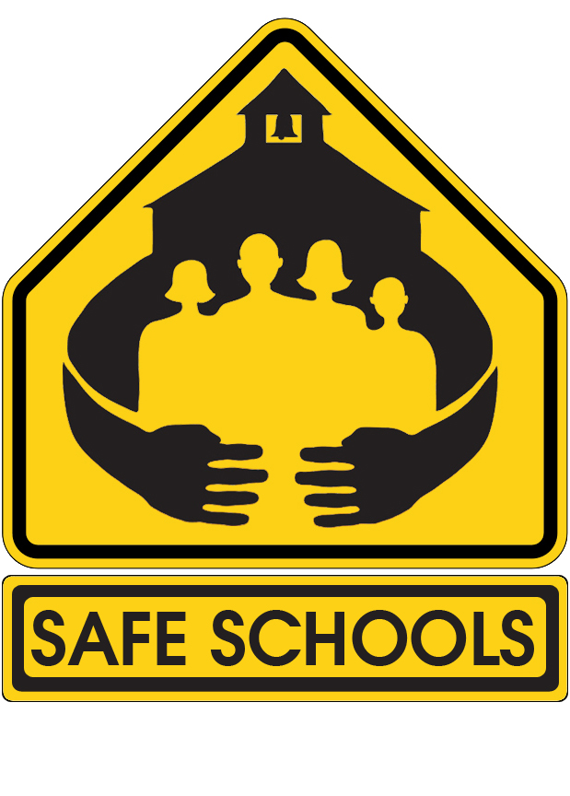
Parents and teachers hold the power to work together to put an end to bullying and provide a safe learning environment for all children. In many cases, it will be the parent who must take charge of bringing the bullying incidents to the attention of school authorities. Parents should expect full cooperation from the school to resolve the problem. The result of reducing bullying in our schools is an improved school environment that is friendly and welcoming to all students. In schools where children feel protected from bullying, they are free to spend their days learning, building friendships, and dreaming about all the possibilities for their lives.

